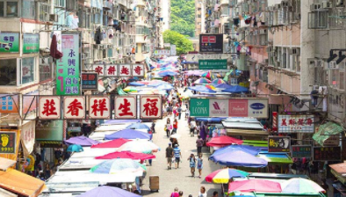

Copy point: STREET PHOTOGRAPHY TIPS in HK

KV landing: [**http://buddy.discoverhongkong.com/eng/buddy-mongKok.html**](http://buddy.discoverhongkong.com/eng/buddy-mongKok.html)

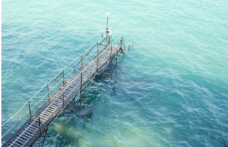

A place with hidden gem <http://buddy.discoverhongkong.com/eng/buddy-saiWan.html>

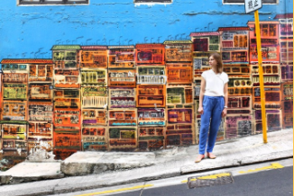

a mix of elements to snap and explore in central <http://buddy.discoverhongkong.com/eng/buddy-oldTownCentral.html>

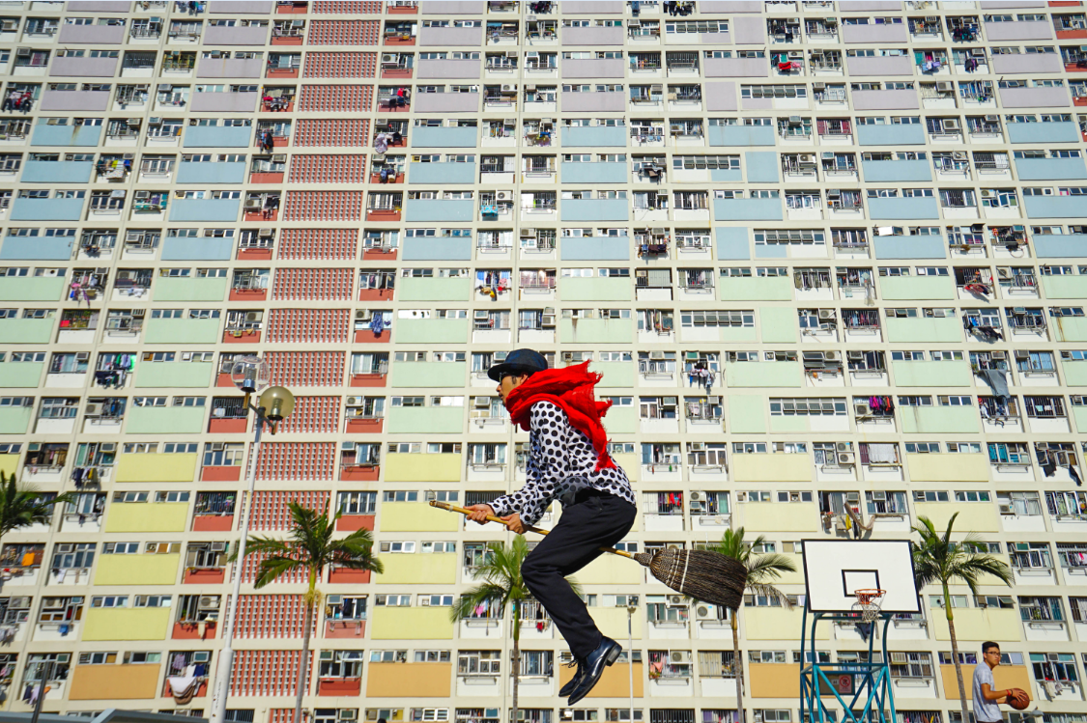

**encourage UGC, Get featured with #DHK**

[**https://www.instagram.com/discoverhongkong/**](https://www.instagram.com/discoverhongkong/)

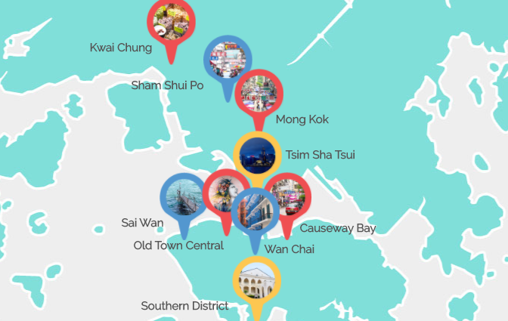

**more districts to explore**

[**http://buddy.discoverhongkong.com/eng/discoverhongkong.html**](http://buddy.discoverhongkong.com/eng/discoverhongkong.html)